HOW TO CREATE A TEST WEB PROJECT WITH SPRING, JSF AND PRIMEFACES (from scratch)

- Open RSA (starting with a new workspace)

- Change to the “Web” perspective
  - Select “Window > Open Perspective > Other…”
  - Check “Show all” check box
  - Select “Web”
  - Click “OK” button

- Create a dynamic web project
  - Select “File > New > Other > Web > Dynamic Web Project”
  - Click “Next” button
  - Type “TestProject3” in Project name: field
  - Click “Finish”

Result: The following is created:
- Dynamic Web Project
- EAR Project

- Create a HTML (web page) under “WebContent”
  - Right-click on WebContent, Select “New > Other…”
  - Expand “Web” folder
  - Select “HTML”
  - Click “Next >” button
  - Specify File Name for Web Page
    - For example: “firstPage.xhtml”
  - Click “Next >” button

NOTE: You can leave the default template to be used as is, “New XHTML File (1.0 transitional)”

  - Click “Finish” button

NOTE: web pages that are created under /WebContent are public pages; web pages that are created under /WebContent/WEB-INF are private pages

Result:
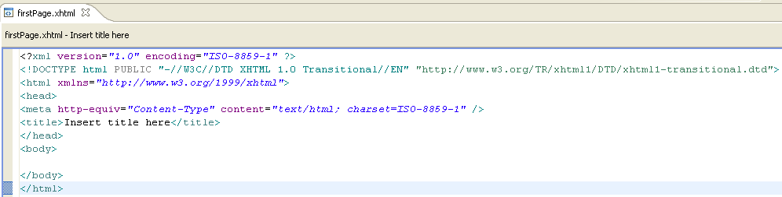

  - Update firstPage.xhtml
    - Format and Add the following line between the <body> tags:

<h1>firstPage.xhtml</h1>

Result
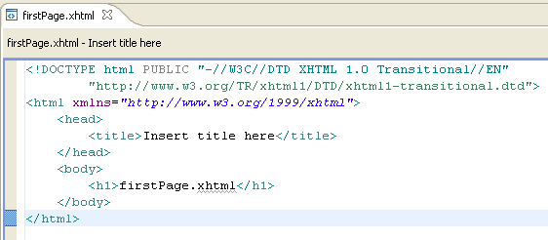

- Configure Server
  - On Server View, initially there will be two server instances:
    - WebSphere Application Server v6.1 at localhost
    - WebSphere Application Server v7.0 at localhost
  - Delete the server instance – v6.1 (since we use v7.0)
    - Right-click on v6.1, Select “Delete”
    - Click “OK” button
  - Configure WebSphere Application Server v7.0 at localhost
    - Double-click on server instance - v7.0
    - Select “Terminate server on workbench shutdown”
    - Save change

- Test - Run firstPage.xhtml
  - Right-click on firstPage.xhtml, Select “Run As > Run on Server”
  - Click “Finish” button

Result:
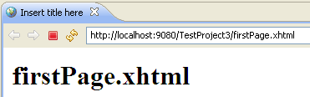

- Add Spring Framework Configuration
  - Copy all Spring JARs from our CPSGEnterprise > lib > spring_core/spring_sec
  - Paste the JARs into “WebContent > WEB-INF > lib”

- Add all the libraries (Spring JARs) to “Java Build Path”
  - Right-click on Project Name, Select “Properties”
  - Select “Java Build Path”
  - Select “Libraries” tab
  - Click on “Add JARs…” button
  - Select (under TestProject > WebContent > lib > spring_core/spring_sec) all JARs
  - Click “OK” button
Result: All JARs are added to list of “JARs and class folders on the build path:”
  - Click “OK”

- Integrate Spring in the application
  - Add a listener to bootstrap the root web application context and Content Configuration location before initialization
In web.xml (under WebContent > WEB-INF), add

<!-- Bootstraps the root web application context before servlet initialization -->
<listener>
<listener-class>org.springframework.web.context.ContextLoaderListener</listener-class>
</listener>

<context-param>
<param-name>contextConfigLocation</param-name>
<param-value>/WEB-INF/application-config.xml</param-value>
</context-param>

  - Update <welcome-file-list> to default to your “firstPage.xhtml”

Example of web.xml:
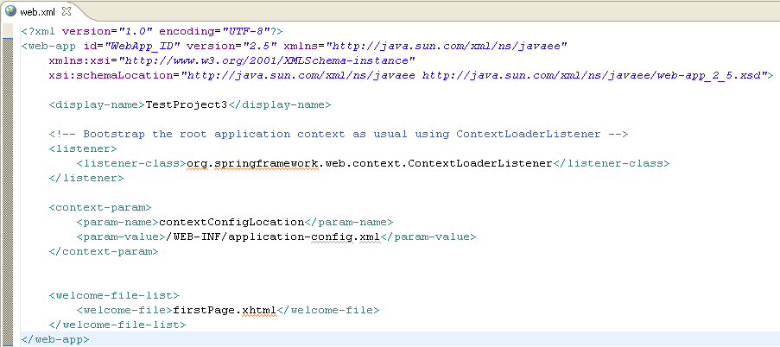

  - Create application-config.xml under “WebContent > WEB-INF”

Example of application-config.xml:

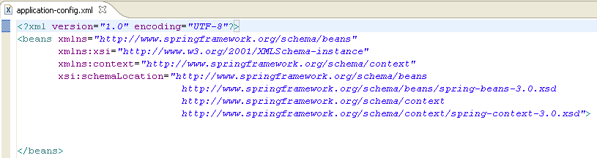

  - Test Spring Integration
    - Run Server and WebApplicationContext should initialize without any errors (see example of Console Output below)

Example of Console Output:

…
[25/09/12 10:23:22:500 EDT] 0000000a ContextLoader I org.springframework.web.context.ContextLoader initWebApplicationContext Root WebApplicationContext: initialization started
[25/09/12 10:23:22:593 EDT] 0000000a XmlWebApplica I org.springframework.context.support.AbstractApplicationContext prepareRefresh Refreshing Root WebApplicationContext: startup date [Tue Sep 25 10:23:22 EDT 2012]; root of context hierarchy
[25/09/12 10:23:22:640 EDT] 0000000a XmlBeanDefini I org.springframework.beans.factory.xml.XmlBeanDefinitionReader loadBeanDefinitions Loading XML bean definitions from ServletContext resource [/WEB-INF/application-config.xml]
[25/09/12 10:23:22:718 EDT] 0000000a DefaultListab I org.springframework.beans.factory.support.DefaultListableBeanFactory preInstantiateSingletons Pre-instantiating singletons in org.springframework.beans.factory.support.DefaultListableBeanFactory@6cff6cff: defining beans []; root of factory hierarchy
[25/09/12 10:23:22:734 EDT] 0000000a ContextLoader I org.springframework.web.context.ContextLoader initWebApplicationContext Root WebApplicationContext: initialization completed in 234 ms
[25/09/12 10:23:22:734 EDT] 0000000a webcontainer I com.ibm.ws.wswebcontainer.VirtualHost addWebApplication SRVE0250I: Web Module TestProject3 has been bound to default_host[*:9080,*:80,*:9443,*:5060,*:5061,*:443].
[25/09/12 10:23:22:734 EDT] 0000000a ApplicationMg I WSVR0226I: User initiated module start operation request completed on Module, TestProject3.war, of application, TestProject3EAR
…

- Add JSF 2.0 MyFaces Configuration
  - Copy all JSF 2.0 MyFaces JARs from our CPSGEnterprise
  - Paste the JARSs in “WebContent > WEB-INF > lib > myfaces”

- Add all the libraries (JSF 2.0 MyFaces JARs) to “Java Build Path”
  - Right-click on Project Name, Select “Properties”
  - Select “Java Build Path”
  - Select “Libraries” tab
  - Click on “Add JARs…” button
  - Select all JARs (under TestProject > WebContent > lib > myfaces > myfaces-core.2.0.11-bin > lib)
  - Click “OK” button
Result: All JARs are added to list of “JARs and class folders on the build path:”
  - Click “OK”

- Integrate JSF 2.0 in application
  - Add listener in web.xml:

<listener>
<listener-class>org.springframework.web.context.request.RequestContextListener</listener-class>
</listener>

  - Add servlet and servlet-mapping to web.xml:

<servlet>
<servlet-name>Faces Servlet</servlet-name>
<servlet-class>javax.faces.webapp.FacesServlet</servlet-class>
<load-on-startup>1</load-on-startup>
</servlet>

<servlet-mapping>
<servlet-name>Faces Servlet</servlet-name>
<url-pattern>*.xhtml</url-pattern>
</servlet-mapping>

- Create faces-config.xml
  - Add <el-resolver> to faces-config.xml

<application>
<el-resolver>org.springframework.web.jsf.el.SpringBeanFacesELResolver</el-resolver>
</application>

Result:
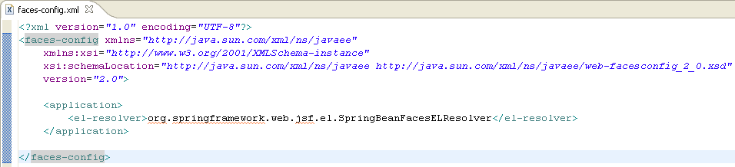

NOTE: Currently, our version of RSA with Eclipse does not support JSF 2.0. In order to use JSF 2.0, we must include the JARs in our library, and then specify the JSF namespaces in the html headers of our web pages. So if you try to enable JavaServer Faces in the project’s properties under Project Facets, it only offers version 1.1 and 1.2 which is not what we want and therefore not enabled. Eventually, when we update to RSA 8, JSF 2.0 will be supported then. This means that we could enable JSF 2.0 in the Properties window and not have to include the JARs like we are doing now.

- Run server.
Result:
Console Output – indicates that the default Faces implementation is used (default Faces is included in current version of RSA/Eclipse).
[25/09/12 10:51:04:524 EDT] 00000020 config I Initializing Sun's JavaServer Faces implementation (1.2_07-b03-FCS) for context '/TestProject3'

Wrong JSF, we want to use JSF 2.0!

RESOLUTION: Set Classloader mode to PARENT_LAST at the EAR and WAR levels
- Right-click on “TestProjectEAR”
- Select “Java EE > Open WebSphere Application Server Deployment”
- Under Application, Select “TestProjectEAR
  - Select Classloader mode: “PARENT_LAST”
  - Select WAR classloader policy: “MODULE”
- Under Application, Select TestProject.war
  - Select Classloader mode: “PARENT_LAST”
- Save Changes

- Run server to verify JSF 2.0 is being used
Result: Another error occurred not related to JSF 2.0
[25/09/12 11:06:52:791 EDT] 00000008 servlet E com.ibm.ws.webcontainer.servlet.ServletWrapper init SRVE0100E: Uncaught init() exception created by servlet Faces Servlet in application TestProject3EAR: java.lang.IllegalStateException: No Factories configured for this Application. This happens if the faces-initialization does not work at all - make sure that you properly include all configuration settings necessary for a basic faces application and that all the necessary libs are included. Also check the logging output of your web application and your container for any exceptions!
If you did that and find nothing, the mistake might be due to the fact that you use some special web-containers which do not support registering context-listeners via TLD files and a context listener is not setup in your web.xml.
A typical config looks like this;
<listener>
<listener-class>org.apache.myfaces.webapp.StartupServletContextListener</listener-class>
</listener>
…

Problem during initialization!

RESOLUTION: Add missing listener to web.xml

<!-- Need to add MyFaces listener manually in web.xml -->
<listener>
<listener-class>org.apache.myfaces.webapp.StartupServletContextListener</listener-class>
</listener>

- Again, Run server to verify JSF 2.0 is being used
Result:
[25/09/12 11:13:53:465 EDT] 00000079 WebConfigPara E Both MyFaces and the RI are on your classpath. Please make sure to use only one of the two JSF-implementations.

You will still get an error, but that is normal. The RI is the mojarro reference implementation that is the default JSF implementation included in the current version of RSA/Eclipse. The MyFaces implementation is the one we have specified to use (JSF 2.0)

- Add Prime Faces 3.3 Configuration
  - Copy all Prime Faces 3.3 JAR from our CPSGEnterprise
  - Paste the JARS in “WebContent > WEB-INF > lib > primefaces”

- Add the library (Prime Faces 3.3 JAR) to “Java Build Path”
  - Right-click on Project Name, Select “Properties”
  - Select “Java Build Path”
  - Select “Libraries” tab
  - Click on “Add JARs…” button
  - Select JAR (under TestProject > WebContent > lib > primefaces >)
  - Click “OK” button

Result: All JARs are added to list of “JARs and class folders on the build path:”

  - Click “OK”

- Create “main.xhtml” web page under “WebContent”
  - Right-click on WebContent, Select “New > Other…”
  - Expand “Web” folder
  - Select “HTML”
  - Click “Next >” button
  - Specify “main.xhtml” as File Name for Web Page
  - Click “Next >” button
NOTE: You can leave the default template to be used as is, “New XHTML File (1.0 transitional)”

  - Click “Finish” button

NOTE: web pages that are created under /WebContent are public pages; web pages that are created under /WebContent/WEB-INF are private pages

- Modify the main(.xhtml) html header tags to the following:

<html xmlns="http://www.w3.org/1999/xhtml"
xmlns:h="http://java.sun.com/jsf/html"
xmlns:f="http://java.sun.com/jsf/core"
xmlns:ui="http://java.sun.com/jsf/facelets"
xmlns:p="http://primefaces.org/ui">

- Create “login.xhtml” web page under “WebContent”
  - Right-click on WebContent, Select “New > Other…”
  - Expand “Web” folder
  - Select “HTML”
  - Click “Next >” button
  - Specify “login.xhtml” as File Name for Web Page
  - Click “Next >” button
NOTE: You can leave the default template to be used as is, “New XHTML File (1.0 transitional)”

  - Click “Finish” button

NOTE: web pages that are created under /WebContent are public pages; web pages that are created under /WebContent/WEB-INF are private pages

- Modify the login(.xhtml) html header tags to the following:

<html xmlns="http://www.w3.org/1999/xhtml"
xmlns:h="http://java.sun.com/jsf/html"
xmlns:f="http://java.sun.com/jsf/core"
xmlns:ui="http://java.sun.com/jsf/facelets"
xmlns:p="http://primefaces.org/ui">

- Update web.xml to have <welcome-file> point to login.xhtml page

- Add a PrimeFaces component to the <body> of main.xhtml to verify if everything was configured properly

<h:form>
<h:panelGrid columns="2" cellpadding="5">
<h:outputText value="Options: " />
<p:selectOneButton value="1">
<f:selectItem itemLabel="Option 1" itemValue="1" />
<f:selectItem itemLabel="Option 2" itemValue="2" />
<f:selectItem itemLabel="Option 3" itemValue="3" />
</p:selectOneButton>
</h:panelGrid>
</h:form>

Example of main.xhtml
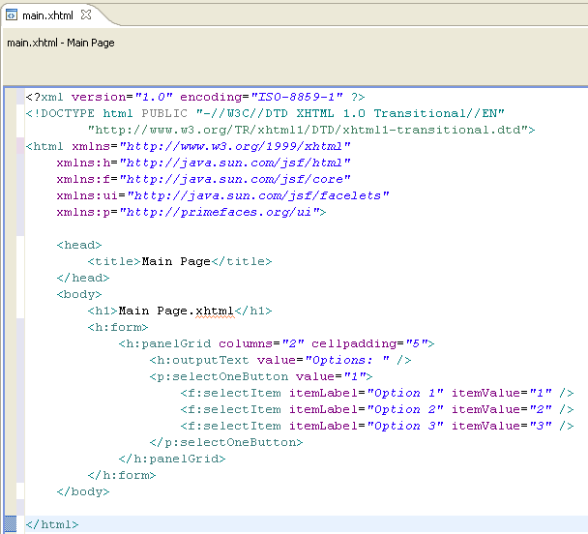

Result of main.xhtml

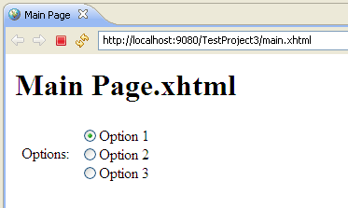

- Add PrimeFaces accordion component from the PrimeFaces showcase (http://www.primefaces.org/showcase/ui/accordionPanel.jsf) to the <body> of firstPage.xhtml

<p:accordionPanel>
<p:tab title="Godfather Part I">
<h:panelGrid columns="2" cellpadding="10">
<p:graphicImage value="/images/godfather/godfather1.jpg" />
<h:outputText value="The story begins as Don Vito Corleone, the head of a New York Mafia family, oversees his daughter's wedding. His beloved son Michael has just come home from the war, but does not intend to become part of his father's business.
Through Michael's life the nature of the family business becomes clear. The business of the family is just like the head of the family, kind and benevolent to those who give respect, but given to ruthless violence whenever anything stands against the good of the family." />
</h:panelGrid>
</p:tab>
<p:tab title="Godfather Part II">
<h:panelGrid columns="2" cellpadding="10">
<p:graphicImage value="/images/godfather/godfather2.jpg" />
<h:outputText value="Francis Ford Coppola's legendary continuation and sequel to his landmark 1972 film, The_Godfather, parallels the young Vito Corleone's rise with his son Michael's spiritual fall, deepening The_Godfather's depiction of the dark side of the American dream. In the early 1900s, the child Vito flees his Sicilian village for America after the local Mafia kills his family. Vito struggles to make a living, legally or illegally, for his wife and growing brood in Little Italy, killing the local Black Hand Fanucci after he demands his customary cut of the tyro's business. With Fanucci gone, Vito's communal stature grows." />
</h:panelGrid>
</p:tab>
<p:tab title="Godfather Part III">
<h:panelGrid columns="2" cellpadding="10">
<p:graphicImage value="/images/godfather/godfather3.jpg" />
<h:outputText value="After a break of more than 15 years, director Francis Ford Coppola and writer Mario Puzo returned to the well for this third and final story of the fictional Corleone crime family. Two decades have passed, and crime kingpin Michael Corleone, now divorced from his wife Kay has nearly succeeded in keeping his promise that his family would one day be completely legitimate." />
</h:panelGrid>
</p:tab>
</p:accordionPanel>

Result:
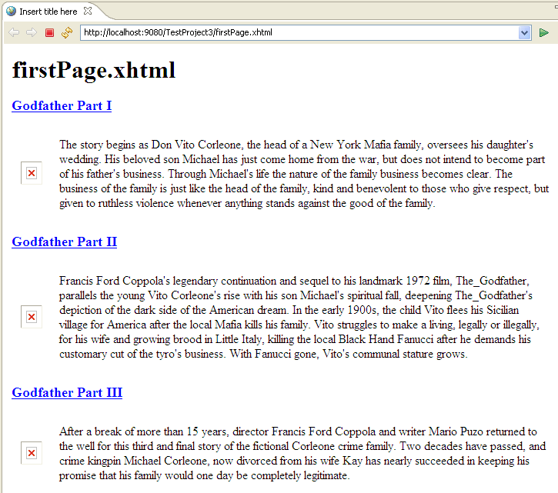

- Navigate from login.xhtml page to firstPage.xhtml
  - Add in login.xhtml:

<f:view contentType="text/html">
<h:head>
<title>Login Page</title>
</h:head>

<h:body>
<h1>Login Page.xhtml</h1>
<h:form id="form">
<p:panel header="Enter your user name and password">
<h:panelGrid columns="2" id="grid">
<h:outputLabel for="firstname" value="Firstname: *" />
<p:inputText id="firstname" value="#{passwordBean.password1}" required="true" label="Firstname" />

<h:outputLabel for="surname" value="Surname: *" />
<p:inputText id="surname" value="" required="true" label="Surname"/>

<h:outputText value="Password: " />
<p:password id="passwordFeedback" value="#{passwordBean.password2}" feedback="true"/>

<p:spacer width="100" height="10" />
<h:commandButton id="LogOn" value ="LogOn" update="grid" action="#{passwordBean.signOnAction}"/>
</h:panelGrid>
</p:panel>
</h:form>
</h:body>
</f:view>

Result:
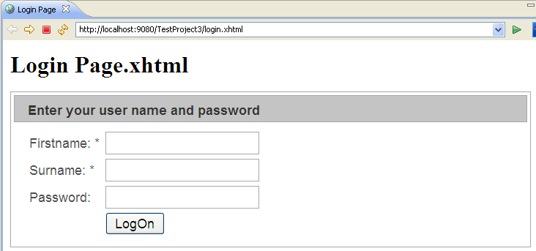

  - Create PasswordBean.java

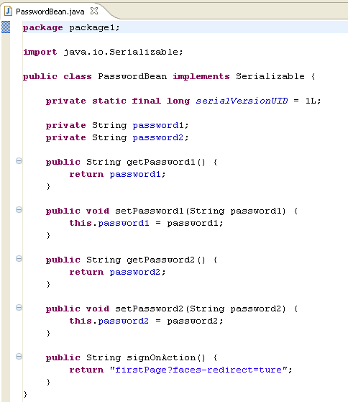

  - Add to application-config.xml:

<bean id="passwordBean" class="package1.PasswordBean">
</bean>

NOTE: Another way to configure your bean is by annotating them instead of adding it to your application-config.xml.
In JSF 2.0, you can annotate a Managed Bean with new @ManagedBean annotation and @Sessionscoped annotation.

  - Error in Console Output when server is started with login.xhtml

[25/09/12 14:30:46:931 EDT] 0000003f servlet E com.ibm.ws.webcontainer.servlet.ServletWrapper service SRVE0068E: Uncaught exception created in one of the service methods of the servlet Faces Servlet in application TestProject3EAR. Exception created : java.lang.NullPointerException
at com.ibm.ws.webcontainer.srt.SRTServletResponse.setContentType(SRTServletResponse.java:1345)
at org.apache.myfaces.application.ResourceHandlerImpl.handleResourceRequest(ResourceHandlerImpl.java:333)
…

After some investigation, it turns out that the server could not handle “PNG” files (http://forum.primefaces.org/viewtopic.php?f=9&t=19134&view=next)

RESOLUTION: Add <mime-type> to web.xml

<mime-mapping>
<extension>png</extension>
<mime-type>image/png</mime-type>
</mime-mapping>

- Add Cascading Style Sheet (CSS) to application

There are 3 ways to insert CSS (http://www.w3schools.com/css/css_howto.asp)
- External style sheet
- Internal style sheet
- Inline style
Ideally, we should use external style sheets because it is applied to many pages

  - Create a “css” folder under WebContent
  - Copy default.css file from “CPSGWeb > web > client > cpsg > css” to “WebContent > css”
  - Add <link> tag to <head> section of login.xhtml to apply default.css

Login.xhtml
<h:head>
<title>Login Page</title>
<link type="text/css" rel="stylesheet" href="#{request.contextPath}/css/default.css" />
</h:head>

Result: Notice that the <h1>Login Page.xhtml</h1> is aligned in the center of the page, instead of left alignment

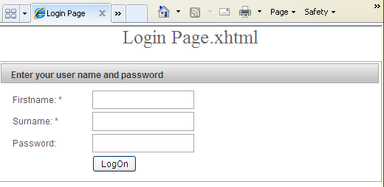

- Add JQuery component (popup window) to application
  - Add to login.xhtml

<a href="http://localhost:9080/TestProject3/firstPage.xhtml">jQuery test</a>
<script>
$(document).ready(function(){
$("a").click(function(event){
alert("Thanks for visiting!");
});
});
</script>

Result:
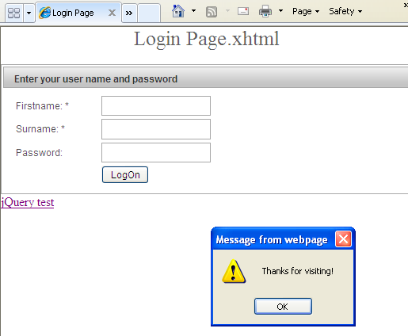

NOTE: Primesfaces already has a version of JQuery included in its jar. Since login.xhtml already has a Primefaces component on its page, the JQuery library will already be loaded without any setup required.

NOTE: If login.xhtml does not have a Primefaces component on its page, then you will need to add:

<h:outputScript library="primesfaces" name="jquery/jquery.js" />

Example: http://docs.jquery.com/How_jQuery_Works

